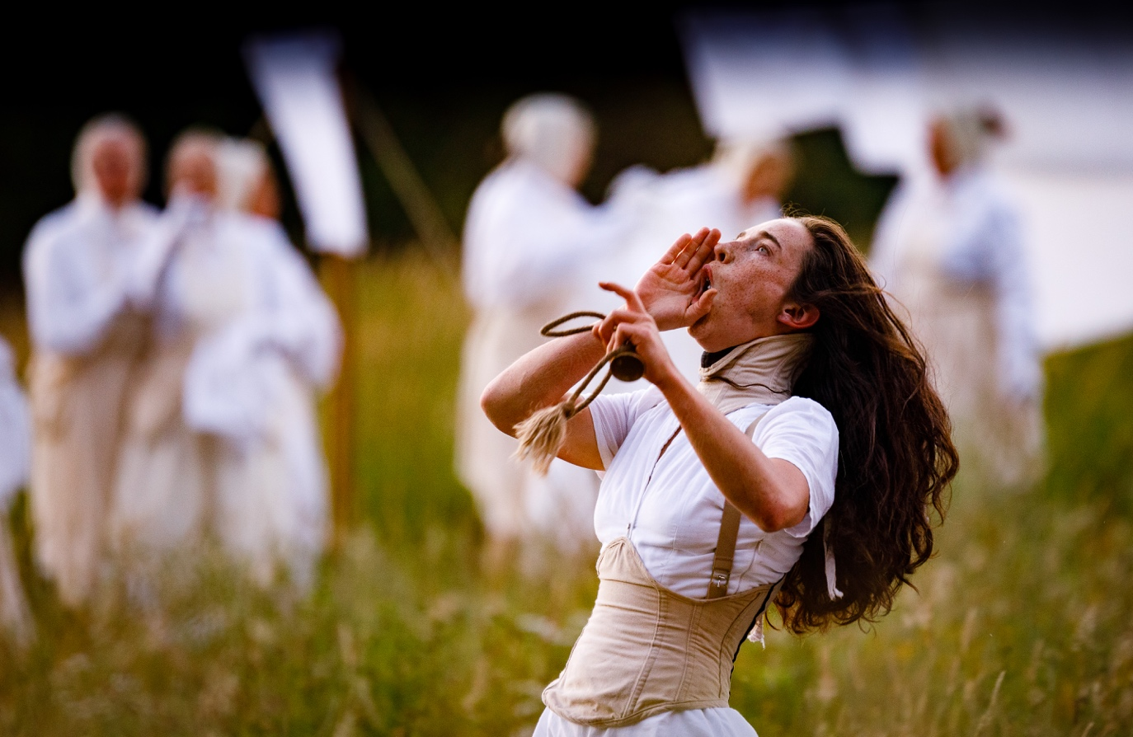

WILDWORKS JOB PACK

COMMUNICATIONS ASSISTANT INTERNSHIP

Wildworks is delighted to present this new internship opportunity which is supported by Cultivator, a project funded by the European Social Fund, Arts Council England and Cornwall Council.

- WHO THIS JOB IS FOR
This is a paid internship and the role is for someone who is looking to develop their skills in professional theatre and will enjoy being involved in a new and exciting outdoor site-specific project.
We recognise that many people experience barriers to working in the arts and it is important that the work we create reflects the whole of our society and that our team is representative of the wide range of communities we engage with. We actively encourage people from a variety of backgrounds with different experiences and skills to join us and continue to develop our working practice. We are particularly keen to hear from candidates from Black, Asian or ethnically diverse backgrounds and candidates who self-identify as disabled and neurodiverse or from a lower-socio economic background.

- THE ROLE

Role: Communications Assistant
Reporting to: General Manager
Duration: 21 weeks (7th February – 1st July 2022)
Hours: 22.5 hours per week. Flexibility across Mon-Friday with some weekend and evenings
Salary: £200.48 per week increasing to £213.75 per week from 1 April 2022 (equivalent to national living wage)
Location: Krowji Ltd, Redruth (with some project location work in St Austell)

Role overview:
To assist with marketing and PR communication for I am Kevin .

Wildworks are offering the chance to work on an exciting new site-specific outdoor production of I am Kevin! This internship is a unique and practical training opportunity to develop your experience of professional communications for a well-known arts organisation.

The Communications Assistant Intern will work directly with Wildworks’ General Manager and freelance Marketing Consultant to produce the comms for Wildworks during the production and delivery of I am Kevin.
Roles and Responsibilities:

- To be the main point of coordination for the marketing schedule for I am Kevin
- To liaise with creative team to develop marketing content
- To coordinate and schedule the social media posts for I am Kevin across Facebook, Instagram and twitter
- To upload content to Youtube and vimeo
- To liaise with external PR agency and press enquiries
- To work with General Manager and Executive Director to create e-newsletters

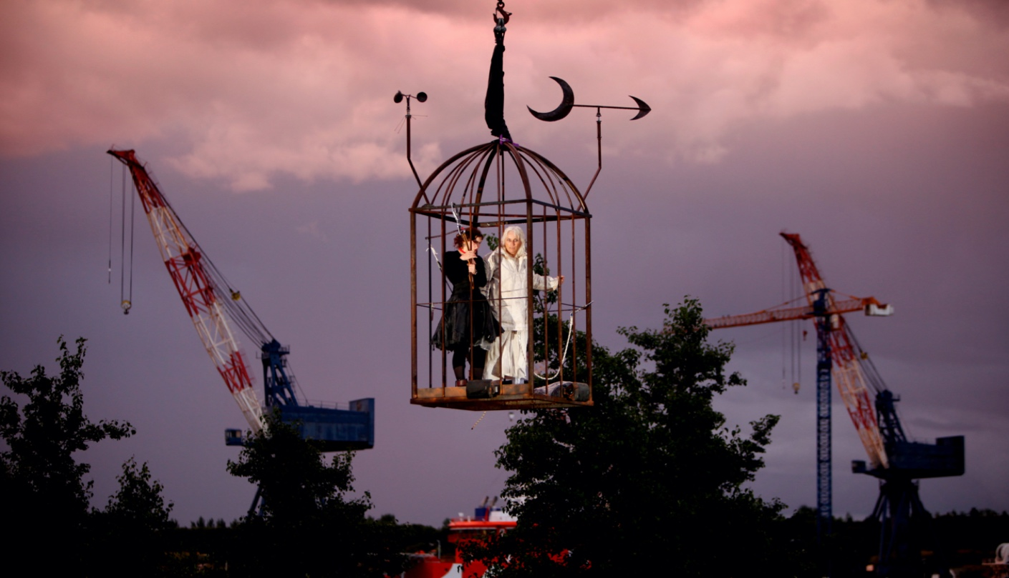

- WHO WE ARE

Wildworks makes landscape theatre. The projects can happen anywhere but in theatre venues- large scale spectacular performances or small intimate artworks that grow out of their locations; quarries, cliffs, harbours, derelict industrial sites, castles, empty department stores... And we work with the people who belong to these places to make the shows. They help us by telling us their stories and memories, and by donating their skills and passions. Narrative is at the centre of our work. We bring the seeds of a story to a site and weave in the strands that tie people and place together.
https://wildworks.org.uk

Our values are:-

Brave - We take calculated risks and make difficult, bold decisions.
Experimental - We create a playground for new ideas, to try new techniques, work with new people and explore impossible conversations. We are prepared for some of these to work and others to fail.
Fluid - We are shapeshifters. No two projects are the same. We are always evolving and adapting to the world around us. We can change direction quickly and without hesitation if we need to.
Human - People are at the heart of everything we do. We are hosts. We tell everyday human stories. Everyone’s invited.

We use these values to help guide us and to help us make decisions if we’re uncertain for both company and artistic pursuits.

We’re a team of people with slightly different skills that come together to make theatre projects wherever and whenever we can and with the widest range of people.

As a small team we all muck in. Everyone makes the tea, goes out to get the biscuits, tidies up and tries to fix the printer. Everyone gets a piece of the creative action and everyone has a voice and the power to make a difference to the work that we make and the people we make it for.

The Wildworks salaried team is currently a full time Executive Director and Artistic Director and part time General Manager and Finance Manager. The wider Company is made up of freelance multi-disciplined artists. As a registered charity, a Board of Trustees governs Wildworks. The team expands when we’re delivering a project (e.g. 50+ freelance creative and production team and 200+ participants).
The artistic programme generally consists of two types of work; shows initiated from an idea from the Artistic Team and work that we have been invited to develop. Although our work is often many years in the making and programming five years ahead is not unheard of, we try not to restrict possibilities for future Wildworks shows. Projects come along all the time and if instinctively it feels like a suitable match (artistically satisfying, good for the Company and rewarding for the individuals involved) – we will be flexible across schedules, scale and locations in order to make an exciting project happen.

- WHERE WE ARE

We have a studio at Krowji Ltd in Redruth but we also set up temporary offices at our project sites. I am Kevin will be based in St Austell.

- WHO YOU ARE

It’s important that you believe and share our values when we’re working together. We make theatre for people who love theatre AND people who think they don’t like theatre. Maybe you don’t like theatre (yet!) but you’re interested in bringing your skills and passion to our projects. We need you to work hard, be proactive and look for ways to help at all times, to be on alert for problems on the horizon or spot things you think could be done differently.

We’re interested in what you bring as an individual and your lived experiences, not purely what employment experience you have. Your current job or previous job may be completely different to this one so we’re keen to learn more about your general attitude and approach to work. You may already be pursuing and developing your own creative practice, not necessarily theatre, either as part of your current job or an interest/hobby.

Personal specification:

Knowledge, skills and experience:

- Good knowledge of theatre and live event practices
- Excellent copy writing and verbal communication skills
- Good computer and database skills
- Experience of creating content for social media
- A relevant degree level qualification or equivalent experience

Personal attributes:

- Strong team player
- Clear and confident communicator
- Excellent organisational skills
- Good attention to detail
- Calm under pressure
- Self-motivated, flexible and positive attitude
- Passion for working outdoors in all weathers!

You must:
- Be able to be based in Cornwall for the duration of the internship

- WHAT YOU WILL GET IN RETURN

You will be supported by the Wildworks in the following ways, to ensure you have a valuable learning experience whilst with the company:

- Company induction with Executive Director and General Manager which will include setting learning objectives for your internship
- Regular check ins with the General Manager
- Evaluation meeting at the end of the internship
- Signposting to future developmental opportunities and/ or training

In addition to the salary we will provide:-

Equipment: Equipment required to fulfil your role will be provided
Holiday: Pro rata based on hours worked
Training: Throughout the internship we will support with on-the-job training.
Network building: During your time with us we will create and support opportunities to meet with other organisations to help build your network

- HOW TO APPLY

Please send us...

- A letter or 3 min film stating why you are interested in the post and how you meet the knowledge, skills and experience criteria
- An up-to-date CV
- Contact details for two referees (At least one referee should be/have been your employee). We will not make direct contact with them without seeking your permission)

Complete our equal opportunities monitoring form by clicking the link below
- Equal opportunities monitoring form

Applications should be emailed to Gwen Scolding- General Manager, gwen@wildworks.org.uk clearly stating in the email subject ‘name- application for Wildworks Communications Assistant Internship.

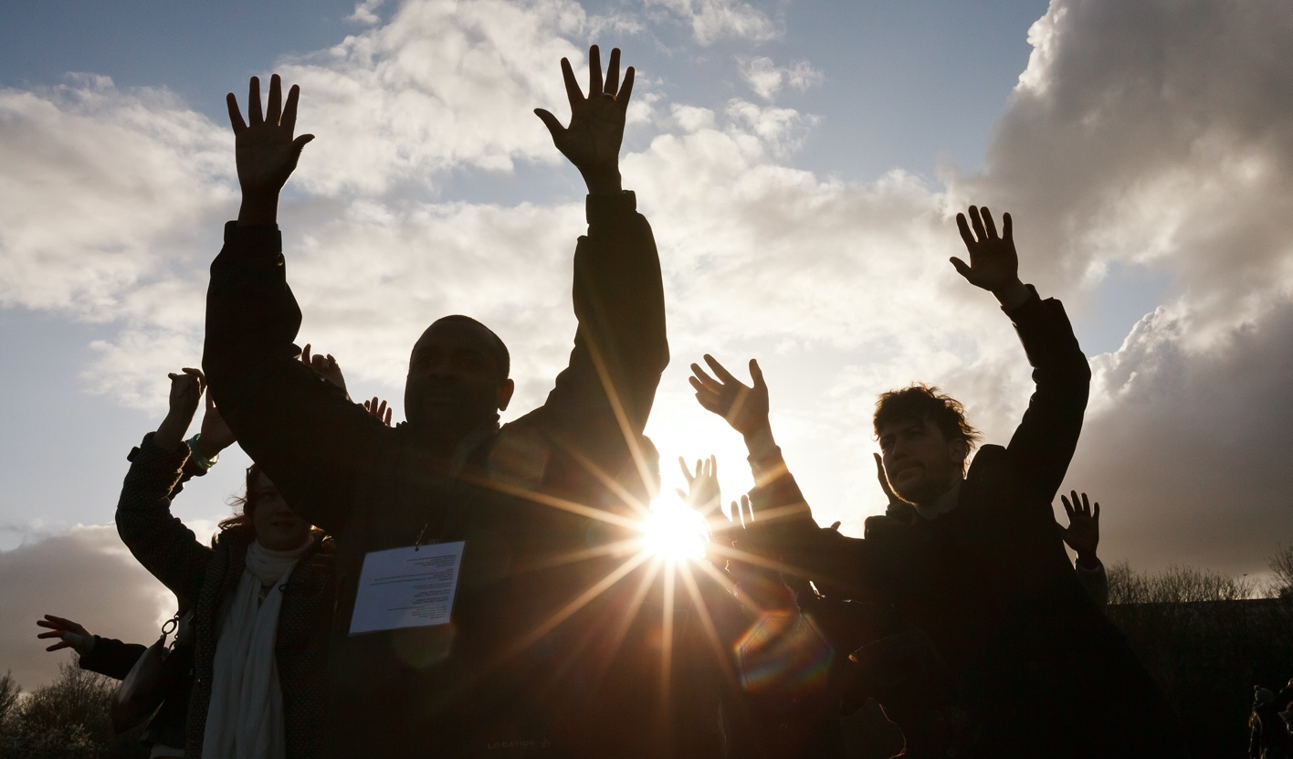

- SELECTION PROCESS AND TIMELINE

Application deadline: 9am Monday 13 December 2021
Interviews: January 2022
Role begins: Mon 7th February 2022

If selected to come to interview, we will contact you to arrange a time and discuss whether this will be over the phone or using video conference platform. We will ask you a set of questions that we will send you in advance and you can ask us questions before, during or after our questions.

We recognise that some people experience disabling barriers or racism and we will interview any applicant who identifies as experiencing these barriers and who meets the job criteria and we are committed to supporting any access requirements at interview or if appointed.

