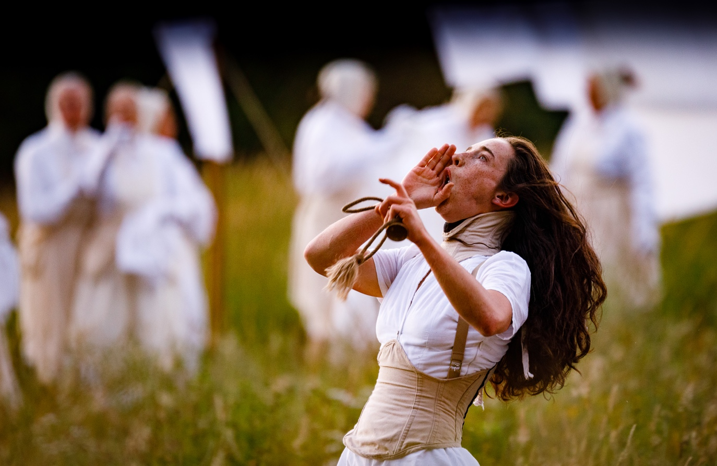
WILDWORKS JOB PACK

COMMUNITY RESEARCH & PARTICIPATION COORDINATOR INTERNSHIP

Wildworks is delighted to present this new internship opportunity which is supported by Cultivator, a project funded by the European Social Fund, Arts Council England and Cornwall Council.

- WHO THIS JOB IS FOR
This is a paid internship and the role is for someone who is looking to develop their skills in professional theatre and will enjoy being involved in a new and exciting outdoor site-specific project.
We recognise that many people experience barriers to working in the arts and it is important that the work we create reflects the whole of our society and that our team is representative of the wide range of communities we engage with. We actively encourage people from a variety of backgrounds with different experiences and skills to join us and continue to develop our working practice. We are particularly keen to hear from candidates from Black, Asian or ethnically diverse backgrounds and candidates who self-identify as disabled and neurodiverse or from a lower-socio economic background.

- THE ROLE

Role: Community Research & Participation Coordinator
Reporting to: General Manager
Duration: 8 weeks (7 February- 31 March 2022)
Hours: 22.5 hours per week. Mon-Friday with weekend and evenings during project delivery
Salary: £200.48 per week (equivalent to national living wage)
Location: St Austell (with potentially some work at the Krowji Office in Redruth, Cornwall)

Role overview: To coordinate community research and participation for I am Kevin

Wildworks are offering the chance to work on an exciting new site-specific outdoor production of I am Kevin! This internship is a unique and practical training opportunity to develop your experience of professional community engagement and management for pioneers and experts in community engagement and participation.

This role supports our creative team working with community groups and individuals in co-creation of show elements.

Roles and Responsibilities:

- Assist Community Researcher and Co-designers on research workshops and engagement activities for I am Kevin
- Coordinate and communicate schedule of engagement
- Coordinate venue hire and organise materials and refreshments required
- Ensure Covid security protocols are in place for participants
- Ensure participants are well looked after during their time on the project
- Assist with expense claims as required for participants

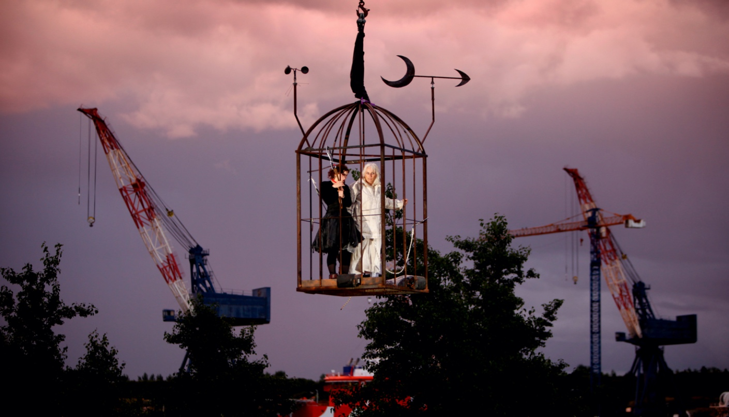

- WHO WE ARE

Wildworks makes landscape theatre. The projects can happen anywhere but in theatre venues- large scale spectacular performances or small intimate artworks that grow out of their locations; quarries, cliffs, harbours, derelict industrial sites, castles, empty department stores... And we work with the people who belong to these places to make the shows. They help us by telling us their stories and memories, and by donating their skills and passions. Narrative is at the centre of our work. We bring the seeds of a story to a site and weave in the strands that tie people and place together.
https://wildworks.org.uk

Our values are:-

Brave - We take calculated risks and make difficult, bold decisions.
Experimental - We create a playground for new ideas, to try new techniques, work with new people and explore impossible conversations. We are prepared for some of these to work and others to fail.
Fluid - We are shapeshifters. No two projects are the same. We are always evolving and adapting to the world around us. We can change direction quickly and without hesitation if we need to.
Human - People are at the heart of everything we do. We are hosts. We tell everyday human stories. Everyone’s invited.

We use these values to help guide us and to help us make decisions if we’re uncertain for both company and artistic pursuits.

We’re a team of people with slightly different skills that come together to make theatre projects wherever and whenever we can and with the widest range of people.

As a small team we all muck in. Everyone makes the tea, goes out to get the biscuits, tidies up and tries to fix the printer. Everyone gets a piece of the creative action and everyone has a voice and the power to make a difference to the work that we make and the people we make it for.

The Wildworks salaried team is currently a full time Executive Director and Artistic Director and part time General Manager and Finance Manager. The wider Company is made up of freelance multi-disciplined artists. As a registered charity, a Board of Trustees governs Wildworks. The team expands when we’re delivering a project (e.g. 50+ freelance creative and production team and 200+ participants).
The artistic programme generally consists of two types of work; shows initiated from an idea from the Artistic Team and work that we have been invited to develop. Although our work is often many years in the making and programming five years ahead is not unheard of, we try not to restrict possibilities for future Wildworks shows. Projects come along all the time and if instinctively it feels like a suitable match (artistically satisfying, good for the Company and rewarding for the individuals involved) – we will be flexible across schedules, scale and locations in order to make an exciting project happen.

- WHERE WE ARE

We have a studio at Krowji Ltd in Redruth but we also set up temporary offices at our project sites. I am Kevin will be based in St Austell so the internship will predominantly be located there.

- WHO YOU ARE

It’s important that you believe and share our values when we’re working together. We make theatre for people who love theatre AND people who think they don’t like theatre. Maybe you don’t like theatre (yet!) but you’re interested in bringing your skills and passion to our projects. We need you to work hard, be proactive and look for ways to help at all times, to be on alert for problems on the horizon or spot things you think could be done differently.

We’re interested in what you bring as an individual and your lived experiences, not purely what employment experience you have. Your current job or previous job may be completely different to this one so we’re keen to learn more about your general attitude and approach to work. You may already be pursuing and developing your own creative practice, not necessarily theatre, either as part of your current job or an interest/hobby.

Personal specification:

Knowledge, skills and experience:

- An interest in theatre and live events
- Interest in working in a participatory workshop setting
- Experience of working in theatre, film or events

Personal attributes:

- Strong team player
- A good people person
- Clear and confident communicator
- Self-motivated, flexible and positive attitude
- Passion for working outdoors in all weathers!

You must:
- Be able to be based in Cornwall for the duration of the internship

- WHAT YOU WILL GET IN RETURN

You will be supported by the Wildworks in the following ways, to ensure you have a valuable learning experience whilst with the company:

- Company induction with Artistic Director and General Manager which will include setting learning objectives for your internship.
- Regular check ins with the General Manager
- Evaluation meeting at the end of the internship
- Signposting to future developmental opportunities and/ or training

In addition to the salary we will provide :-

Equipment: Equipment required to fulfil your role will be provided
Holiday: Pro rata per hours worked and paid at end of internship
Training: Throughout the internship we will support with on-the-job training as required
Network building: During your time with us we will create and support opportunities to meet with other organisations to help build your network

- HOW TO APPLY

Please send us...

- A letter or 3 min film stating why you are interested in the post and how you meet the knowledge, skills and experience criteria
- An up-to-date CV
- Contact details for two referees (At least one referee should be/have been your employee). We will not make direct contact with them without seeking your permission)

Complete our equal opportunities monitoring form by clicking the link below
- Equal opportunities monitoring form

Applications should be emailed to Gwen Scolding- General Manager, gwen@wildworks.org.uk clearly stating in the email subject ‘name- application for Wildworks Community Participation Internship.

- SELECTION PROCESS AND TIMELINE

Application deadline: 9am Monday 13 December 2021
Interviews: January 2022
Role begins: Monday 7th February 2022

If selected to come to interview, we will contact you to arrange a time and discuss whether this will be over the phone or using video conference platform. We will ask you a set of questions that we will send you in advance and you can ask us questions before, during or after our questions.

We recognise that some people experience disabling barriers or racism and we will interview any applicant who identifies as experiencing these barriers and who meets the job criteria and are committed to supporting any access requirements at interview or if appointed.

