



**WILDWORKS JOB PACK**

**Marketing and Communications Manager**

Wildworks is delighted to invite applications for the role of Marketing and Communications Manager.

1. **WHO THIS JOB IS FOR**

Are you passionate about the arts, theatre, community and storytelling? At Wildworks we don’t just make amazing theatre experiences we create community led productions which *“challenge, inspire and delight”\** and right now we are on the lookout for another like-minded human to help share our love for live performance with as many people as possible.

If you are a dynamic and enthusiastic Communications or Marketing Manager looking for a fantastic new opportunity to join a small but growing team, we would love to hear from you. This varied role will be responsible for developing and implementing marketing strategies to drive brand awareness, increase and expand our audiences and grow audience loyalty. You will collaborate with cross-functional teams, manage marketing campaigns, analyse market trends and ensure consistent messaging across all marketing channels.

The ideal candidate will have a proven track record of delivering successful marketing campaigns as well as a deep understanding of marketing principles, strong leadership, excellent communication, networking skills.   
  
We recognise that many people experience barriers to working in the arts and it is important that the work we create reflects the whole of our society and that our team is representative of the wide range of communities we engage with. We actively encourage people from a variety of backgrounds with different experiences and skills to join us and continue to develop our working practice. We are particularly keen to hear from candidates from Black, Asian or ethnically diverse backgrounds and candidates who self-identify as disabled and neurodiverse or from a lower-socio economic background.

1. **THE ROLE**

**Role:** Marketing and Communications Manager

**Reporting to:** CEO

**Duration:**  Starting as soon as possible until 31 March 2025

**Hours:** 22.5 hours per week (3 days)

**Salary:** £33,000 per annum (pro rata)

**Location:** Flexible although will require some time at Hall for Cornwall, Truro (Wildworks base)

**Marketing Responsibilities:**

1. Generate ticket sales and audience numbers for specific productions and events
2. Develop and execute innovative marketing strategies to promote our projects, broaden our audience reach, and achieve business objectives.
3. Create and manage multi-channel marketing campaigns including digital, social media, email, advertising, outdoor and events.
4. Collaborate with internal stakeholders, such as producing and creative teams, to align marketing strategies with overall organisational goals.
5. Collaborate with external project partners to align marketing strategies with joint project objectives.
6. Manage the creation of marketing collateral, including sales materials, website content, blog articles, press releases, and other promotional materials.
7. Oversee the company's digital presence, including website optimisation, search engine optimisation (SEO), and search engine marketing (SEM).
8. Monitor and analyse key performance indicators (KPIs) to evaluate marketing campaign effectiveness and make data-driven recommendations for improvement.
9. Conduct market research to identify target audiences, industry trends, and competitors' activities and collect audience data to support our core funding and project funding contractual requirements
10. Manage marketing budgets, allocate resources effectively, and optimise return on investment for marketing initiatives.

**Wildworks Membership Scheme Responsibilities:**

1. Support the development and implementation of a strategic plan to establish and launch a Wildworks’ membership scheme. Define membership tiers, benefits, and pricing structures that align with our goals and objectives.
2. Plan and execute campaigns to attract new members. Develop strategies to increase membership renewal rates. Evaluate and report on effectiveness.
3. Use newsletters, email and social media to keep members updated and engaged and informed of member benefits i.e.: priority booking, discounts, access to special events
4. Maintain the membership database providing exceptional customer service responding to enquiries, resolving issues, and addressing member feedback.

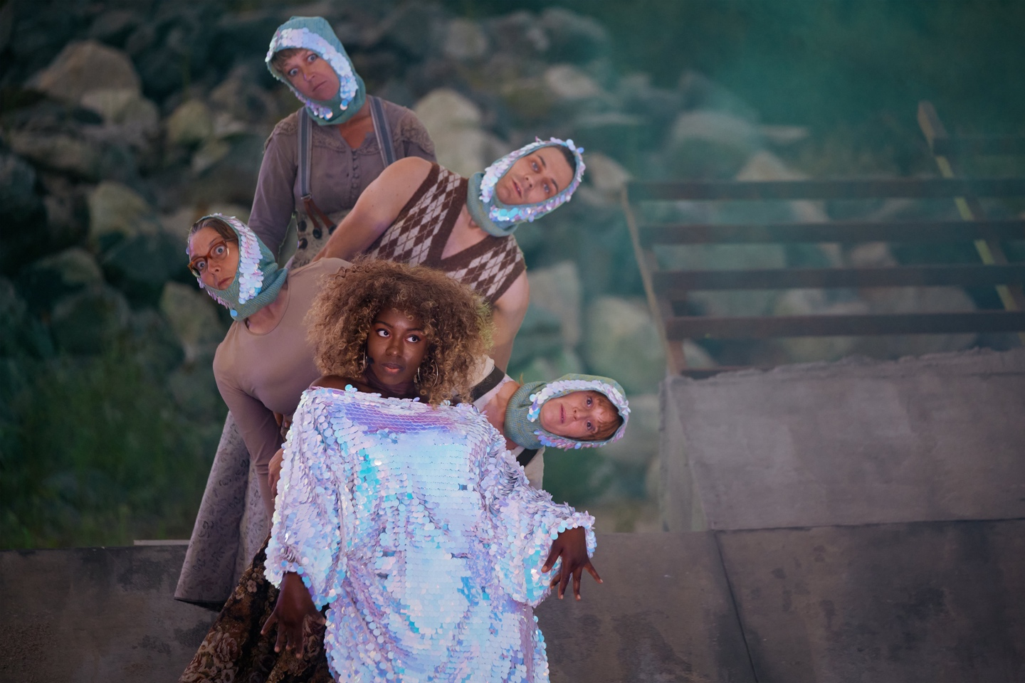

1. **WHO WE ARE**

Wildworks makes landscape theatre. The projects can happen anywhere but in theatre venues- large scale spectacular performances or small intimate artworks that grow out of their locations; quarries, cliffs, harbours, derelict industrial sites, castles, empty department stores... And we work with the people who belong to these places to make the shows. They help us by telling us their stories and memories, and by donating their skills and passions. Narrative is at the centre of our work. We bring the seeds of a story to a site and weave in the strands that tie people and place together <https://wildworks.org.uk>.

**Our values are:-**

**Brave -** We take calculated risks and make difficult, bold decisions.

**Experimental -** We create a playground for new ideas, to try new techniques, work with new people and explore impossible conversations. We are prepared for some of these to work and others to fail.

**Fluid -** We are shapeshifters. No two projects are the same. We are always evolving and adapting to the world around us. We can change direction quickly and without hesitation if we need to.

**Human -** People are at the heart of everything we do. We are hosts. We tell everyday human stories. Everyone’s invited.

We use these values to help guide us and to help us make decisions if we’re uncertain for both company and artistic pursuits.

We’re a team of people with slightly different skills that come together to make theatre projects wherever and whenever we can and with the widest range of people.

As a small team we all muck in. Everyone makes the tea, goes out to get the biscuits, tidies up and tries to fix the printer. Everyone gets a piece of the creative action and everyone has a voice and the power to make a difference to the work that we make and the people we make it for.

The Wildworks salaried team is currently a full time CEO, Artistic Director and part time General Manager and Finance Manager. The wider Company is made up of freelance multi-disciplined artists. As a registered charity, a Board of Trustees governs Wildworks. The team expands when we’re delivering a project (e.g. 50+ freelance creative and production team and 200+ participants).

The artistic programme generally consists of two types of work; shows initiated from an idea from the Artistic Team and work that we have been invited to develop. Although our work is often many years in the making and programming five years ahead is not unheard of, we try not to restrict possibilities for future Wildworks shows. Projects come along all the time and if instinctively it feels like a suitable match (artistically satisfying, good for the Company and rewarding for the individuals involved) – we will be flexible across schedules, scale and locations in order to make an exciting project happen.

1. **WHERE WE ARE**

We have an office at Hall for Cornwall, Truro but we also set up temporary offices at our project sites.

1. **WHO YOU ARE**

It’s important that you believe and share our values when we’re working together. We make theatre for people who love theatre AND people who think they don’t like theatre. Maybe you don’t like theatre (yet!) but you’re interested in bringing your skills and passion to our projects. We need you to work hard, be proactive and look for ways to help at all times, to be on alert for problems on the horizon or spot things you think could be done differently.

We’re interested in what you bring as an individual and your lived experiences, not purely what employment experience you have.

**Qualifications & Qualities:**

* Bachelor's degree or equivalent qualification in Marketing, Business Administration, or a related field or 5+ years experience in a Marketing or Communications role.
* Experience in Sponsorship and exceeding targets would be an advantage but is not essential
* Experience of setting up or running a loyalty programme would be an advantage but not essential. However, strong analytical skills, with the ability to interpret complex data, identify trends, and make data-driven decisions is essential.
* Proven experience in a fast-paced dynamic environment, experience in the arts / theatre would be a distinct advantage.
* Demonstrable success in developing multi-channel marketing campaigns in particular digital marketing, social media and print
* Proficiency in using marketing automation tools, CRM systems, and analytics platforms.
* Good understanding of market research techniques and experience of running surveys and analysing insight.
* Excellent written and verbal communication skills, with the ability to craft compelling copy and content and communicate complex concepts effectively.
* Highly organized, detail-oriented, and able to manage multiple projects simultaneously under tight deadlines.

1. **WHAT YOU WILL GET IN RETURN**

You will be supported by the Wildworks in the following ways:

**Equipment:** Equipment required to fulfil your role can be provided

**Holiday:** 28 days inc Bank Holidays per year (pro rata)

**Pension:** Work place pension (opt out option)

**Accommodation/Mileage:** Travel to our place of work in Truro is not covered. Mileage to other locations as part of your duties as required.

1. **HOW TO APPLY**

Please send us...

* A letter or 3 min film stating why you are interested in the post and how you meet the knowledge, skills and experience criteria
* An up-to-date CV
* Contact details for two referees (At least one referee should be/have been your employee). We will not make direct contact with them without seeking your permission)

Complete our equal opportunities monitoring form by clicking the link below

* [[Equal opportunities monitoring form](https://forms.office.com/Pages/ResponsePage.aspx?id=HCGtF1kT0U2_8Wm4Sb4kQUU22fwz5JBErq4d-ZUuJypUQVRWWlE1V1pMVFJEUzUzSU1DOVBRT1VENy4u)](https://forms.office.com/r/Cnx499VrD0)

Applications should be emailed to Emma Hogg- CEO, [emma@wildworks.org.uk](mailto:gwen@wildworks.org.uk) clearly stating in the email subject ‘name- application Comms and Marketing Manager’

1. **SELECTION PROCESS AND TIMELINE**

Application deadline: 9am, Monday 13th November

Interviews: 20th November – 24th November

Role begins: As soon as possible

If selected to come to interview, we will contact you to arrange a time and discuss whether this will be in person or via video conference platform. We will ask you a set of questions that we will send you in advance and you can ask us questions before, during or after our questions.

