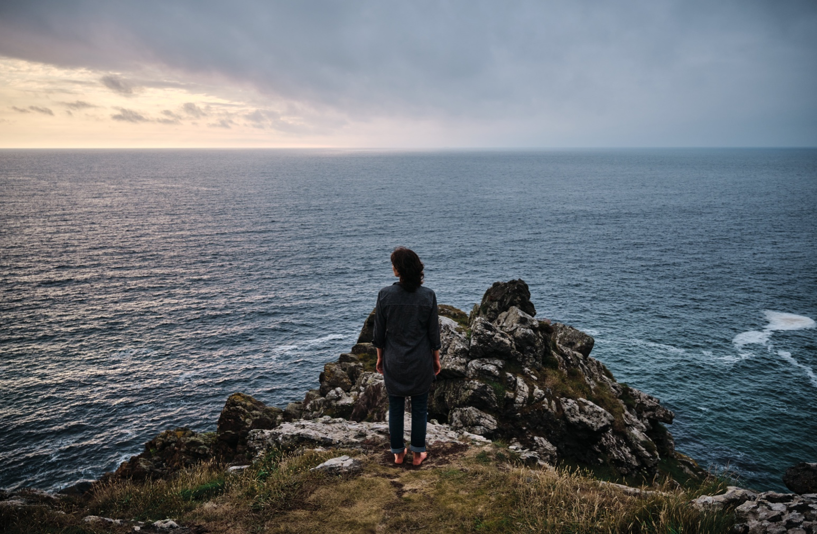

**SPONSORSHIP BRIEF**

Wildworks is looking to commission an external Sponsorship Consultant to bring in private sector sponsors for our new project, ‘We are Shining’. This is a new Wildworks project consisting of four strands of activity part funded by the Shared Prosperity Fund. There is a sponsorship target that fulfills one element of the additional income required to deliver this ambitious programme at its fullest potential.

**LOCATION**: The work can be delivered remotely, however a base in Cornwall would be an advantage and professional knowledge of Cornwall desirable. A hot desk in our office at Hall for Cornwall, Truro can be made available when required.

**REPORTING TO**: The consultant will report to Wildworks’ CEO.

**DATE OF CONTRACT**: 6 to 12 months from November 2023 to October 2024 with majority of deliverables being required within the first 6 months.

**DELIVERABLES:**

* Develop a sponsorship strategy for Wildworks and more specifically the ‘We Are Shining’ programme
* Agree with the Wildworks CEO the strategy and potential sponsors to approach, ensuring the company values align
* Represent Wildworks in approaching potential sponsors and lead on negotiations
* Deliver £55,000 sponsorship

**FEE AVAILABLE:** up to £5,500 including VAT payable in two instalments or upon the total target being achieved if sooner.

**APPLICATION:**

## Letter of application detailing relevant experience and previous work no more than 2 A4 pages

## CV

## Confirmation available to work within timescales

## Deadline 9am, 13 November 2023

## CONTRACT AWARDED BY 20 November 2023

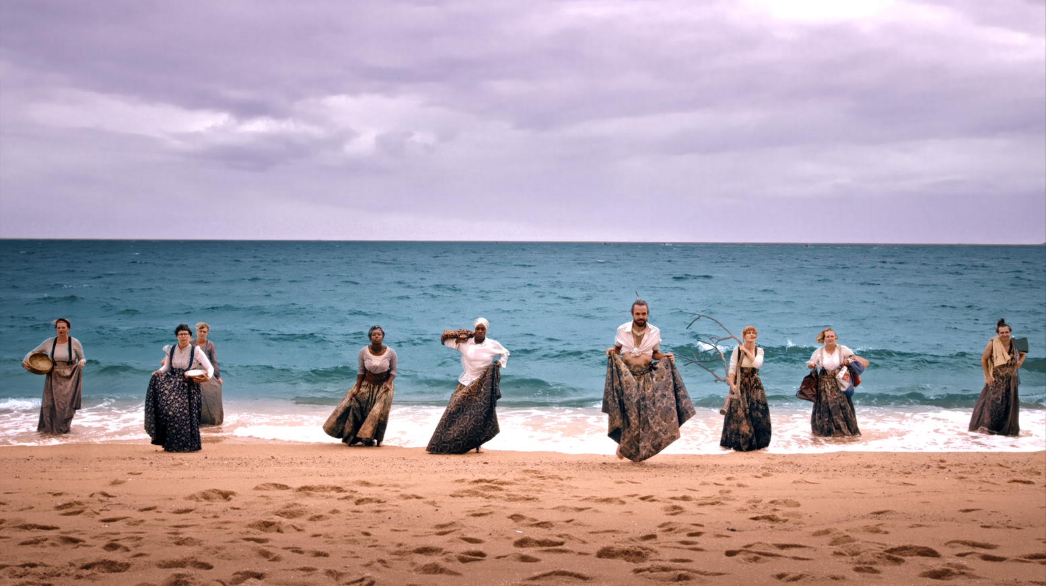

**BACKGROUND INFORMATION**   
**WILDWORKS PROJECT- WE ARE SHINING**

**WE ARE SHINING is** a year-long journey inspired by the journey of Pytheas, the Greek explorer. A sailor, merchant, scientist … and the first person to circumnavigate and document the British Isles in 320BC, gathering the stories of Belerion, ‘The Shining Land’, which we now call Cornwall.

What would an explorer find when arriving from the great blue beyond today?

How would we describe ourselves? Our history and myths, our character, our everydayness and our rarity? What do we value and who do we want to share it with?

With fantastic imagery, story, song, immersive experiences, fire and laughter, this programme will explore, collect and re-imagine what this ‘Shining Land’ means for us.

**ACTIVITY:**

We have planned four distinct strands of activity involving a range of local and national partners;

1. **HELLO STRANGER:** A comprehensive community engagement programme
2. **RE:WILD:** A training programme that will equip individuals with new practical skills and tools. RE:WILD will also develop Cornwall’s internal networks, channels of communication and opportunities to collaborate, which are crucial if the creative sector is to thrive.
3. **WILDLINGS:** A small-scale touring model of installations and performances
4. **XENOS:** A Wildworks trademark large scale, free, multi day event across Cornwall that brings communities and visitors together for live and digital audiences.

**AMBITION FOR REACH:**

We have the following targets for participation, audience and marketing reach

Total audience (live and digital) engagement inc participation of volunteers: 72,000

Xenos large event across Cornwall: 12,500

Marketing reach: 250,000

**PREVIOUS SPONSORS:**

We have had previous success with sponsorship for our Cornwall theatre shows and these include:-

Sharps Brewery

Clean Earth Energy

The Cornwall Hotel and Spa

Classic Cottages

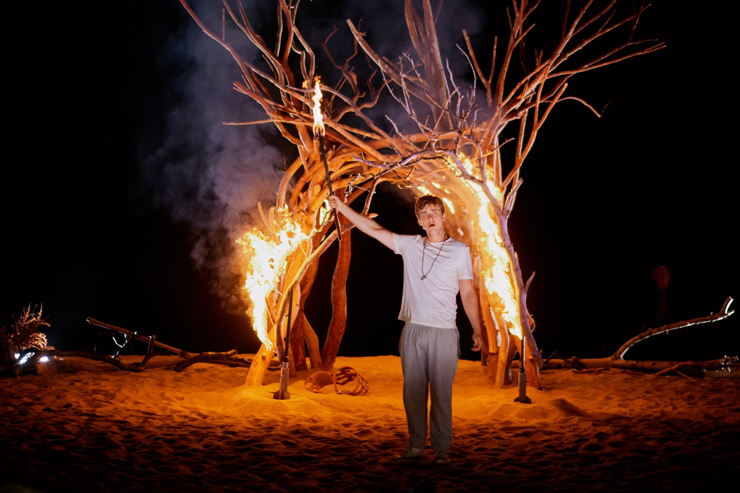

## CORNWALL AND ISLES OF SCILLY [GOOD GROWTH FUNDING](https://ciosgoodgrowth.com/about/)

As part of the UK Government’s Levelling Up agenda, Cornwall and Isles of Scilly have been allocated £132million for local investment through the [Shared Prosperity Fund](https://www.gov.uk/government/publications/uk-shared-prosperity-fund-prospectus/uk-shared-prosperity-fund-prospectus). The primary goal of the SPF is to build pride in place and increase life chances across the UK with three clear investment priorities:

1. COMMUNITY AND PLACE

* Spread opportunities and improve public services, especially in those places where they are weakest
* Restored sense of community, increase local pride of place and sense of belonging, especially in areas where these are lost or reduced
* Homicide, serious violence and neighbourhood crime to fall
* Empower local leaders and communities, especially in those places lacking local agency

2. SUPPORTING LOCAL BUSINESS

* Boost productivity
* Increase pay
* Increased employment
* and living standards by growing the private sector, especially in those places where they are lagging

3. PEOPLE & SKILLS

* Improved high quality skilled training
* Increase in opportunities, jobs and pay
* Increase in healthy life expectancy and reduce the gap between life expectancy in different areas of the country
* Improved health and wellbeing and life chances, with the gap between top performing and lowest performing areas closing

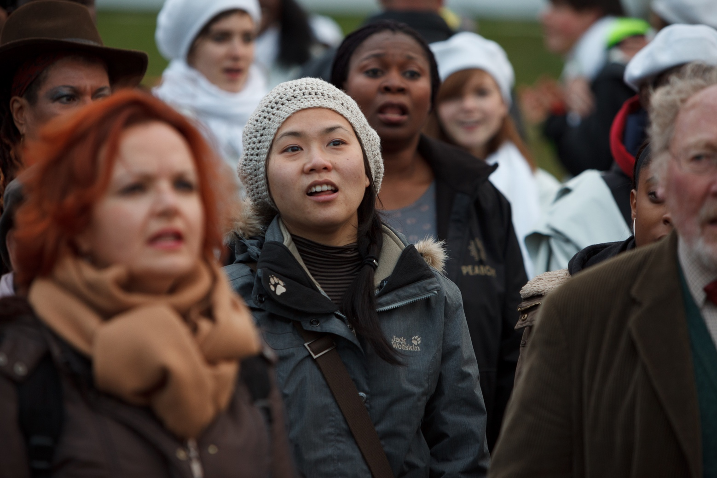

## More about Wildworks

Wildworks is the UK’s leading landscape theatre company. From our base in Cornwall, we make site-specific theatre with communities locally, nationally, and internationally. We reach audiences and collaborators all over the globe. Everyone is invited. Our work attracts people who do not go to the theatre. We can be found on beaches and in woodlands, car parks, nightclubs, and disused quarries, anywhere from derelict department stores to medinas, and from refugee camps to castles.

Collaboration and partnerships are central to our process. The lived experience of local people is at the heart of our work and without their participation, the work cannot happen. Our process starts with conversations, often with marginalised communities, who help us shape the telling of everyday human stories in ways that are both familiar and re-imagined.

We started in Cornwall, and Cornwall remains our emotional and physical home. Many of our company members and associates live here and we draw inspiration from Cornwall’s extraordinary natural and post-industrial landscape. We continue to build on the county’s long history of working outdoors, turning Cornwall’s lack of infrastructure into a positive, by working in the landscape rather than traditional theatre venues.

Our practice is shaped by the defining features of Cornwall: a place in which artists naturally collaborate across art-forms and with communities; a peninsula somewhere on the edge that looks outwards to the world.

Our work is predominantly site-specific live performance with elements of exhibition, audio/visual, digital media, and film. We tell universal stories in ways that are highly visual, making use of diverse media. Our productions resonate and are enjoyed by people across all ages and cultural backgrounds. An important part of our purpose is to support the next generation of landscape theatre makers and artists. Everything we do is measured against our values: human, brave, fluid and experimental.

Wildworks has delivered 33 projects, in 21 countries, with over 45,000 participants, to audiences of over one million.

You can find out more about how our work impacts on those who work or participate with us [here](https://wildworks.org.uk/support-us/)

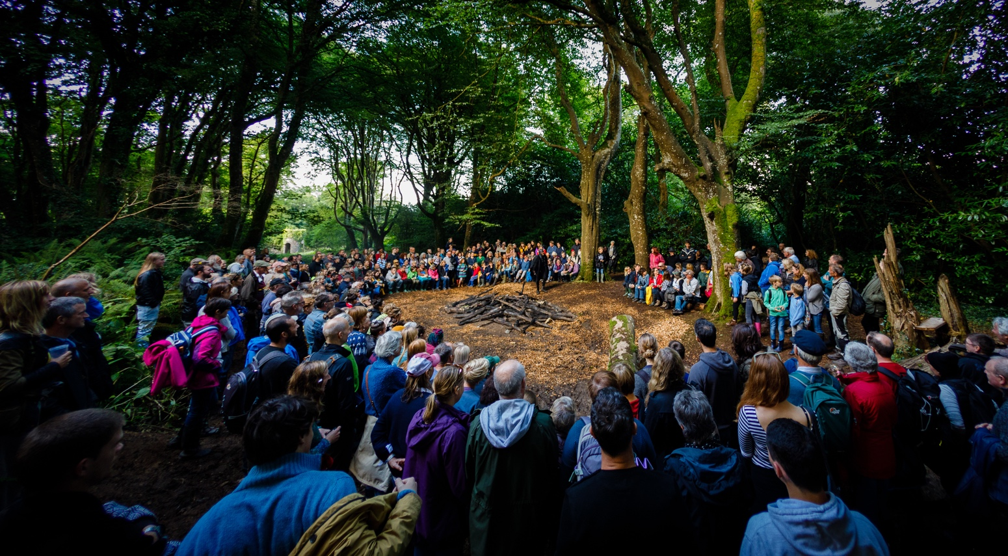

### Community Process

Wildworks is deeply committed to, and has extensive knowledge and experience of, co-creating complex, multi-year projects with a diverse range of communities across the UK and world. We have worked in under-served communities in the UK, (Port Talbot, Sunderland), as well as in scenic but economically deprived landscapes like Mevagissey. We have brought profile and prestige to community work over the past two decades and are internationally celebrated for visionary ambition and delivery.

The heart of Wildworks’ process is enabling individuals to express themselves in the context of their community, history, and landscape. We explore a place and the people who live there before we settle on a story, characters, or theme for the project. We do this by talking to residents about their lives and dreams. We continually test new methods for working and engaging community participation.