
Board of Trustees
Recruitment Pack
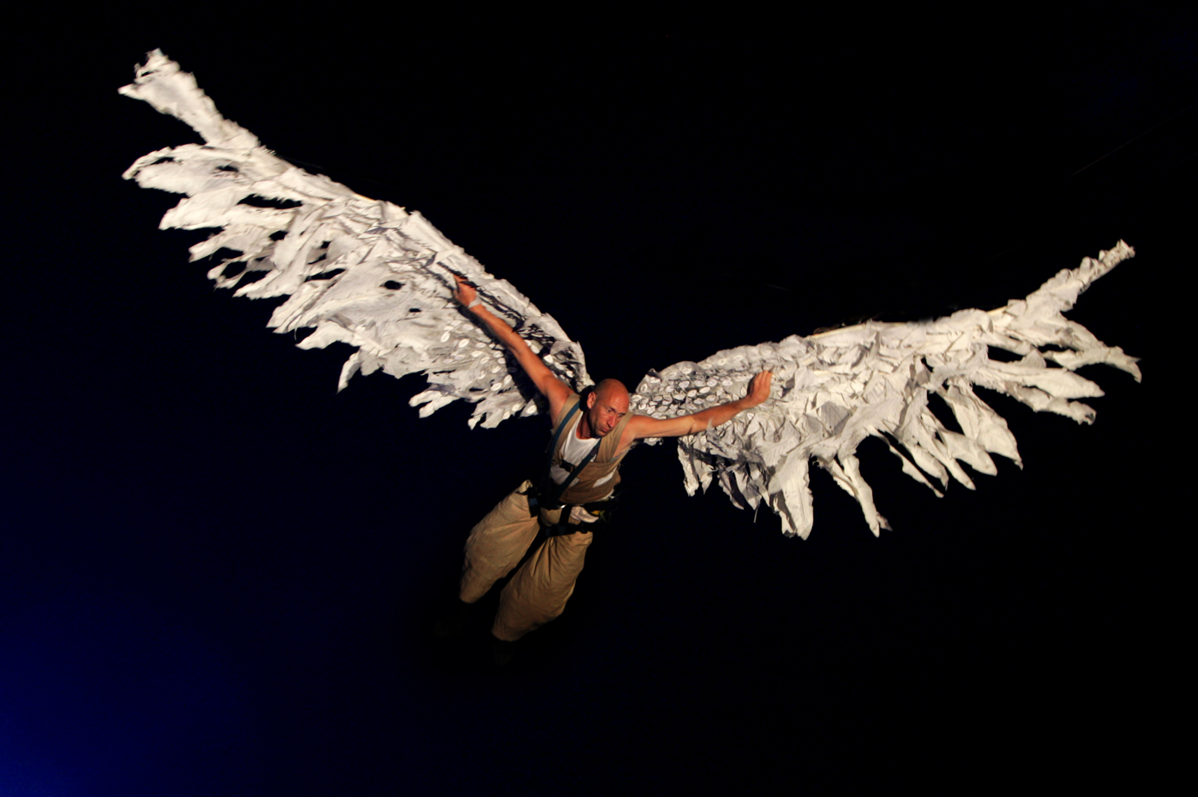WILDWORKS are Britain’s leading
landscape theatre company
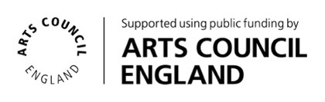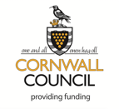
Travaux Sauvages Ltd t/a Wildworks - HUSA, Hall for Cornwall, Truro, TR1 2LL
Company number 06161282 Registered charity number 1139598 VAT registration number 932128542
JOIN OUR BOARD!
Thank you for considering joining our board at this exciting time of evolution for the organisation. At the end of 2024, the Wildworks Board of Trustees appointed a new co-leadership team, Gwen Scolding (Executive Director) and Nathan Jackson (Executive Producer), with a bold and inspiring vision for the future of Wildworks.

Now, as 2025 begins, we are looking for the right people to join our existing Board of Trustees, and to work with Wildworks’ leadership team in shaping the company’s future. This is a great opportunity for people from all backgrounds and communities to be part of Wildworks, to help develop how the company is run and to support the organisation’s ongoing development.

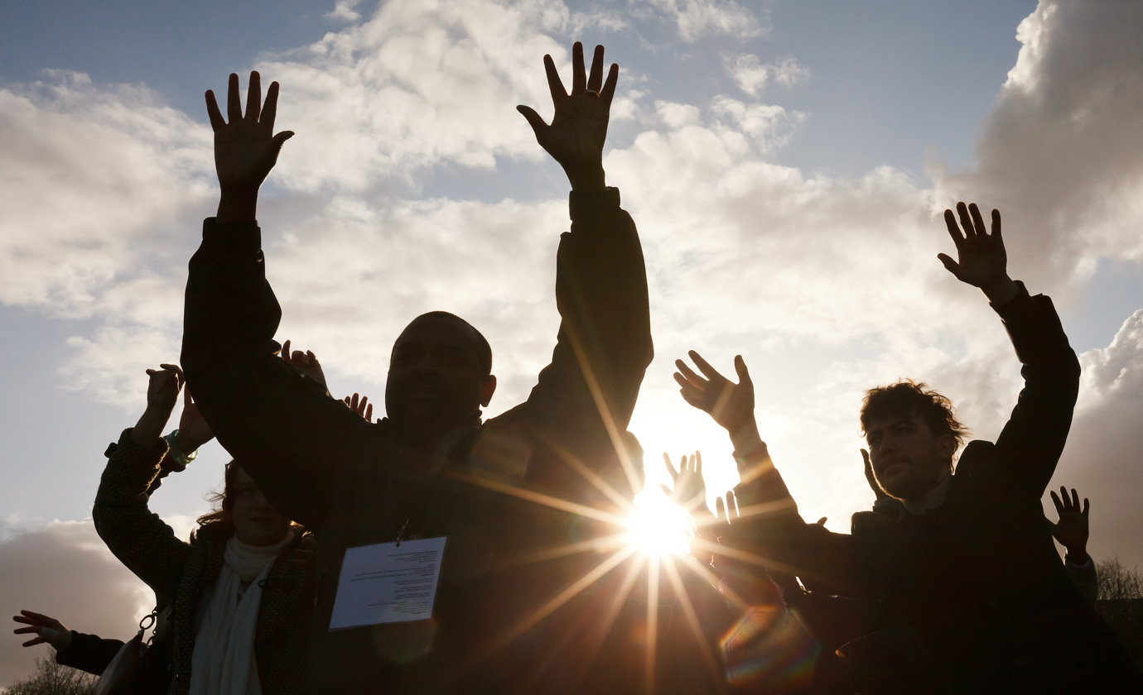

We know that lots of people aren’t sure what being on a board of trustees means, or what the requirements are so this pack will give you a little more information regarding what’s involved, and what we’re looking for. However, if you’ve still got questions, we love to chat, so please get in touch.
You can find out more about the company and the people who currently look after it by browsing our website and by following us on social media – Instagram, X, Facebook.
We look forward to hearing from you!
HELLO.
IS IT YOU WE’RE LOOKING FOR?
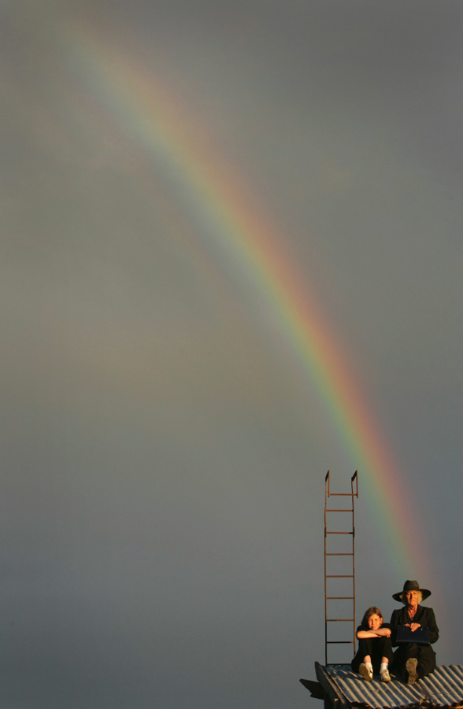

We are looking for a maximum of 3 people to join the Wildworks board.
We’re also specifically looking for people interested in the role of Chairperson, for which we are seeking someone with particular experience and expertise.
The other trustee roles are open to all skills and backgrounds and we welcome interest from everyone, whether you’ve been on a board before or not. We acknowledge that the mix of people currently on boards within the UK arts and cultural sector does not reflect the diversity of the population or communities in society more broadly. We are committed to supporting applications from people who haven’t been on boards before and are willing to learn more about what is involved.

WHO ARE WE?
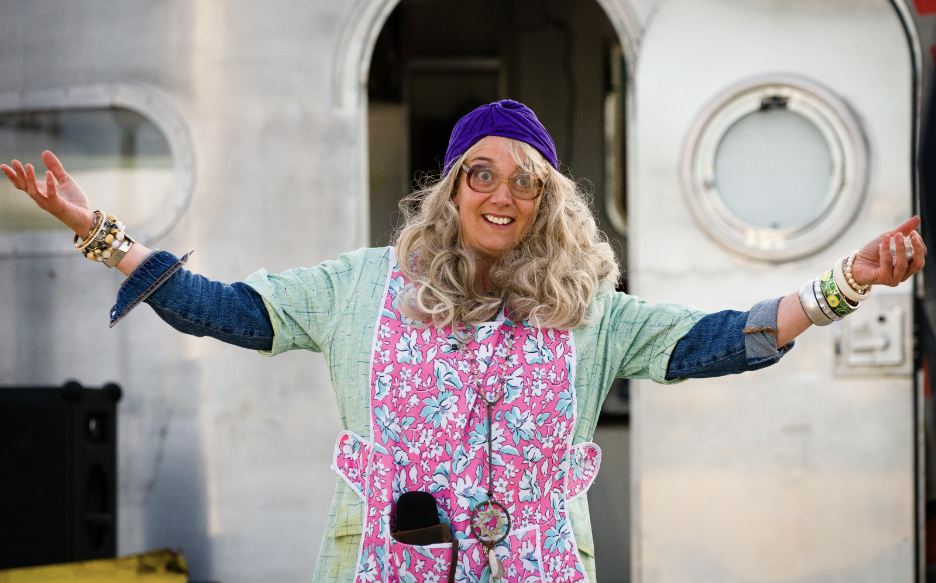

Wildworks is an international art-led theatre company, based in Cornwall and founded in 2005 to create site-specific theatrical events and installations. We balance high production values with a distinctive commitment to community engagement; and believe that community is a simple but profound conjuncture of people and place. Our shows happen in landscapes and other non-traditional theatre spaces. They reflect and embrace the host communities from which they draw their meaning.
Our work often happens in places on the edge; of conflict, of social change & loss of major industry, of rural isolation.
Our work appeals to people of all backgrounds and ages and attracts diverse and new audiences because it is fundamentally embedded in the narratives of contemporary societies. We invite participants to join us in familiar spaces, from all ages and backgrounds. Anyone can join us in both performing and production roles. We find them through formal and informal routes or they find us.
The artistic programme generally consists of two types of work– shows initiated from an idea from within the Company and work that we have been invited to develop by external commissioners. Although our work is often many years in the making and programming, five years ahead is not unheard of, we try not to restrict possibilities for future Wildworks shows. Projects come along all the time and if instinctively it feels like a suitable match (artistically satisfying, good for the Company and rewarding for the individuals involved) – we will be flexible across schedules, scale, form and locations to make an exciting project happen.
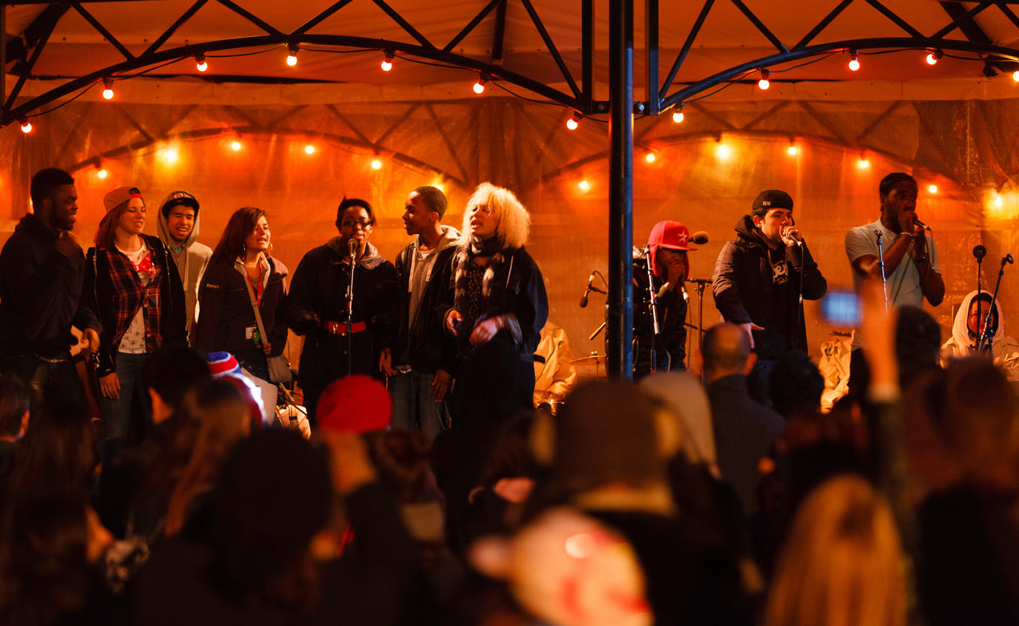

We produce, commission and create new work in a variety of forms, empowering, supporting and inspiring writers and theatre artists to tell stories that reach diverse audiences.
Wildworks has a light organisational footprint to ensure the highest proportion of budgets find their way to the work. Currently the Company is based in a small office at the Hall for Cornwall in Truro and an industrial unit near Redruth.
We are proud to be a National Portfolio Organisation (NPO), with regular funding from Arts Council England until 2026. We are also a Creative Client of Cornwall Council with funding in place until 2026.
In 2024/25 we are delivering our most ambitious programme to date, We Are Shining.

OUR VALUES, VISION AND MISSION
Our values are:
Brave
We take calculated risks and make difficult, bold decisions.
Experimental
We create a playground for new ideas, to try new techniques, work with new people and explore impossible conversations. We are prepared for some of these to work and others to fail.
Fluid
We are shapeshifters. No two projects are the same. We are always evolving and adapting to the world around us. We can change direction quickly and without hesitation if we need to.
Human
People are at the heart of everything we do. We are hosts. We tell everyday human stories. Everyone’s invited.
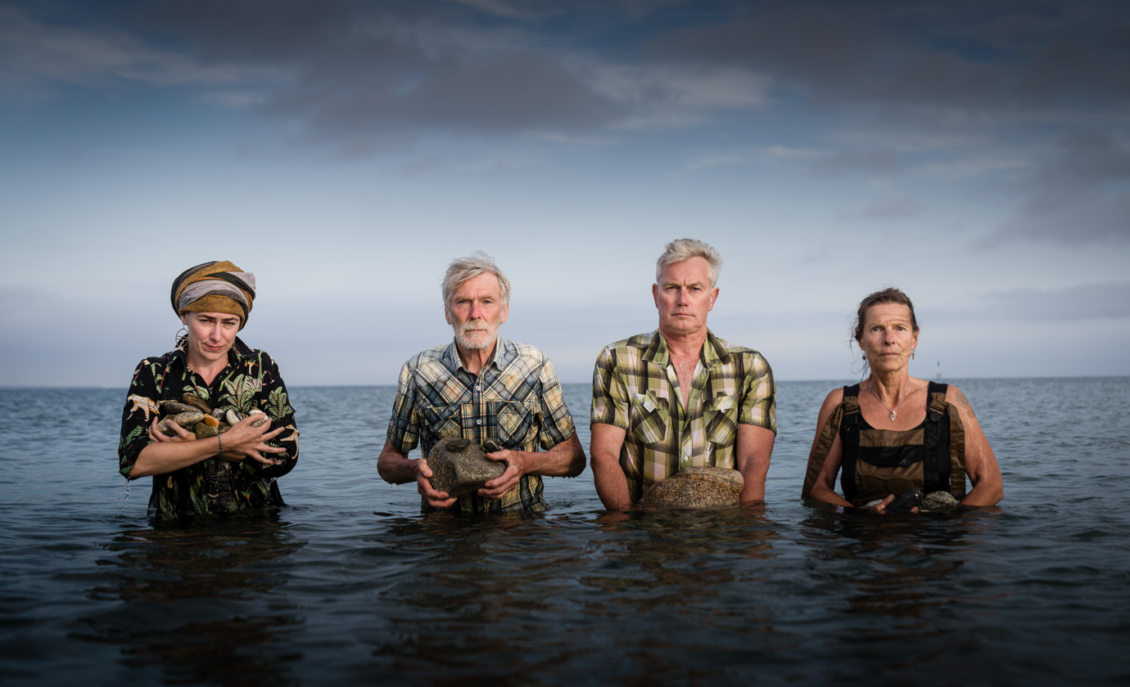

We use our values to help make decisions about projects and company development.
The work we make constantly evolves as new collaborations take us into different places. Partnership working is an essential part of the Wildworks process – to help us realise our big aspirations for each project and to influence the work creatively.
Drawing power from people, Wildworks’ strength lies in plurality of form, fluidity of artistic relationships, flexibility of creative approach and a passionate integrity of purpose.
20 years on from the company’s inception we continue to be the exemplar in British landscape theatre. We are constantly innovating in our practice, artistically and technologically, and we aim to produce our work as sustainably as possible. We strive to become the ambassadors; sharing our knowledge and experience and inspiring future generations of theatre makers.
The new executive team is now working closely with the Board of Trustees to build on the legacy that Wildworks has created over the past 20 years and to forge a new and exciting path that drives the company forward.
We are excited about the future and the potential of the projects we have in development, with various ideas currently being cooked up in a programme of R&D activity.

MANAGEMENT, GOVERNANCE & THE BOARD OF TRUSTEES
The Wildworks staffing team is:
Executive Director & co-CEO : Gwendolen Scolding
Executive Producer & co-CEO: Nathan Jackson
Associate Director: Kyla Goodey
Finance Manager: Debra Gristwood
Finance Assistant: Mackenzie Thompson
Production Co-ordinator: Izzy Wilkinson
The Wildworks Associate Artists are currently:
Mercedes Kemp (Founding Artist), Sue Hill (Founding Artist), Ellie Williams, Amy Pitt, Vicky Abbott, Josh Pharo and Steve Tanner.
The wider Company is made up of freelance multi-disciplined artists.
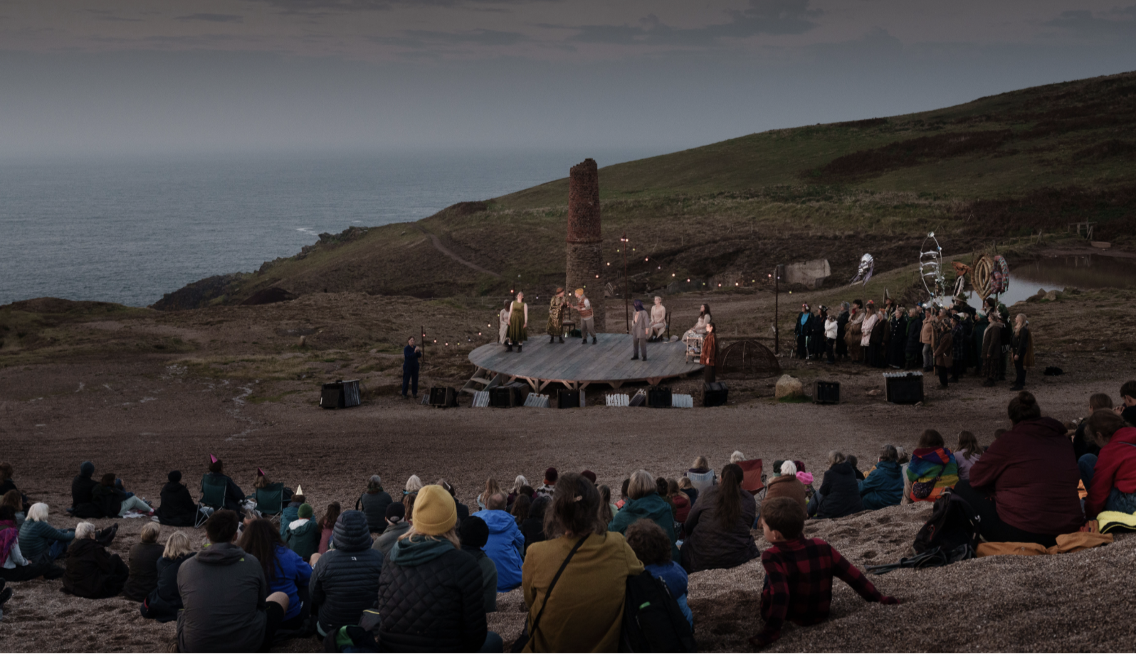

As a registered charity, Travaux Sauvages Ltd t/a Wildworks is governed by the Board of Trustees which oversees the work of the charity and provides strategic advice and support to the executive team.

The Wildworks Board of Trustees is currently:
Chairperson: Julia Webb-Harvey
Board Members: Fran Branfield, Jane Moss, Mikey Martins, James Chapman, Ellie Woolman
The Board of Trustees meet online on a quarterly basis. There is usually one in-person meeting each year. To ensure effective governance and support for the executive team we seek to balance the range of skills and experience amongst the trustees to match the needs of the organisation. We recognise the importance in having a Board that reflects the communities that we work within and encourage applications from individuals with diverse backgrounds.
The Board of Trustees are vital to the smooth running of the company. We have no fewer than 3 board members at any given time, and a maximum of 7. Board membership is confirmed at the annual general meeting.
Our board members advise us, hold us to account, and champion our work in Cornwall and beyond. Our current board members have expertise in the arts, in business, the public sector, education, marketing, and accounting.
Some are Cornwall-based and others are further afield. Geography is not a barrier; we meet online and in-person.
We do not expect all board members to be experienced in all areas of governance however we do ask all board members to:
- Commit to the vision and values of Wildworks
- Take part in the board’s collective decision-making
- Scrutinise business planning and ensure robust financial management
- Accept the legal duties and responsibilities of trusteeship
- Be an ambassador for Wildworks, championing our work and helping to secure new partners and sponsors
- Attend four board meetings a year including the AGM and an away-day
- Provide advice and support to the executive team
- Attend Wildworks events and shows

Training and support is available, including mentoring if appropriate, so previous experience as a trustee is not essential.
Board members of charities do not get paid to be on boards. However, the company will reimburse any reasonable expenses (e.g. travel or childcare) incurred by attending board meetings and Wildworks is committed to covering costs incurred by any additional access needs of prospective and current board members, such as BSL signing services.
Board members are initially appointed for a three-year term. Board members may be reappointed at the discretion of the Chair. You are of course free to step down at any time.
There is lots of information about the governance of charities and the roles and obligations of Trustees at www.charitycommission.gov.uk.

COULD YOU BE OUR CHAIRPERSON?
We are looking for someone to take on the role of Chairperson for our Board of Trustees. This is a vital role and we are keen to find the right person. In short, the role of the chairperson is to:
- Lead the Board of Trustees
- Ensure smooth running of board meetings
- Promote good governance among fellow charity trustees
- Provide supervision and support to the executive team
- Act as a figurehead or spokesperson where required
Ideally, you will have experience in a senior organisational leadership role and be able to bring the knowledge and expertise you’ve gained through your work to the Chairperson role.
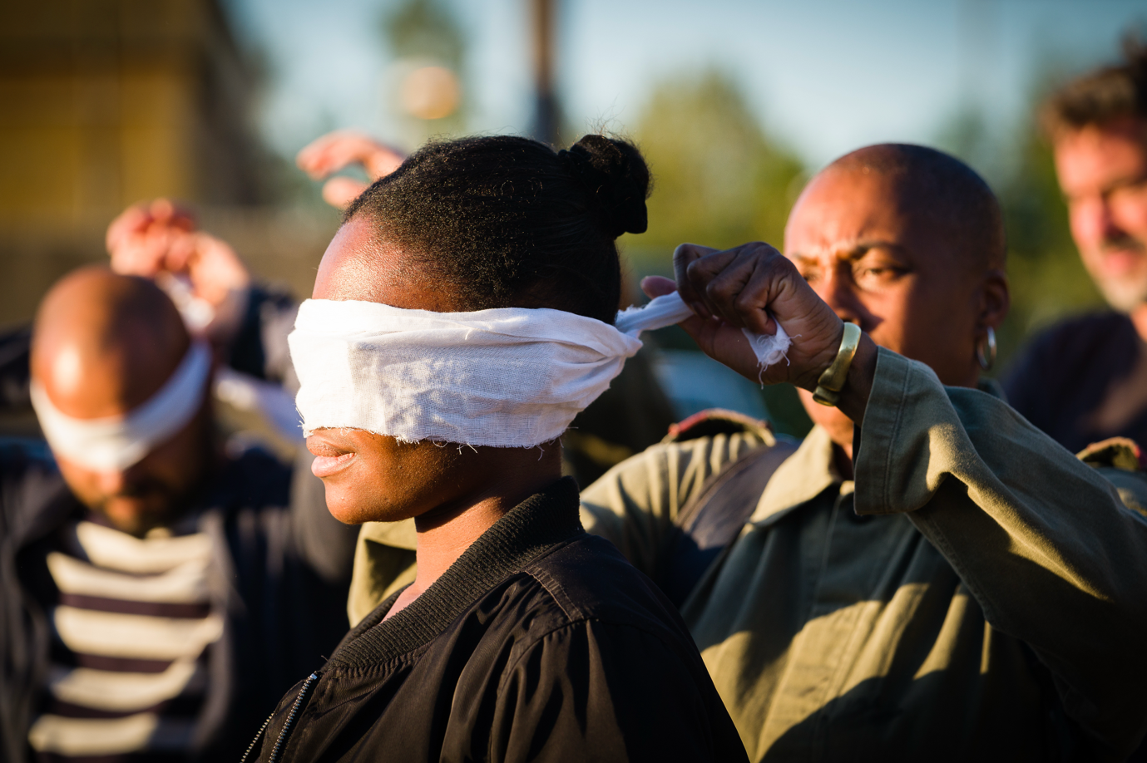

STILL READING AND TEMPTED?
We do hope that you have found all the information you need to fully consider joining our Board of Trustees or become our Chairperson. The next stage is for you to get in touch to register your interest. When you do, we would like you to consider these three questions:

- Who are you?
- Why does being on the board of Wildworks interest you?
- What relevant skills or experience do you have that you would you bring to our board? Or, if relevant, to the role of Chairperson?

We don’t expect any more than a few sentences for each question. You can send over a CV if that helps to introduce yourself and give us a sense of your past work and experience.

Or if you prefer to record a video or audio file or send your answers to these questions in any other format then let us know.

Once you’ve got in touch, we’ll organise a short informal online chat with a member of our board and our leadership team, to hear a little more about what is involved, discuss the current priorities of the board and the role in more detail. If we feel like it’s the right fit for both parties, then we’ll invite you to come to a board meeting so you can make sure you are happy before officially joining the board.

If you’ve any questions or queries about then please don’t hesitate to get in touch. You can call Nathan on 07747 834255 or email nathan@wildworks.org.uk

Julia Webb-Harvey, our current Chair, is also available for an informal chat or to answer any further questions.

Please email gwen@wildworks.org.uk or nathan@wildworks.org.uk to register your interest.
Deadline to register your interest – 31st January 2025

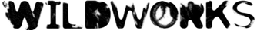
All photographs by Steve Tanner

